
2007 Version

Wire Rope Computer Detector
MTCwindows System

Operation

Manual

上海且华虚拟仪器技术有限公司
SHANGHAI QIEHUA VIRTUAL INSTRUMENT CO．，LTD
List

- Outline 4
- System Demand 5
- Computer Hardware Disposition Demand 5
- Software Environment Demand 5
- System Disposition 5
- Software Installation 6
- Visual Basic Plug-in Unit Package Installation 6
- MTC Windows Special-purpose Software Installation 6
- USB to RS232 Actuation Installation 6
- System Operation 7
- Hardware Connection 7
- Whole Connection 8
- Sensor Installation 8
- Software Operation 10
- System Operation Flow 26
- Parameters Setting and Calibration 26
- Serial Number Setting 27
- Diameter and Metallic Cross-sectional Area Setting 27
- Lay pitch Setting 27
- Sampling Interval Setting 28
- Broken Wire Parameter Calibration（LF） 28
- Wave Form Reduce Rate Setting 32
- Related Deterioration Parameter Calibration（LMA） 32
- Flaws Analysis Evaluation 36
  - Goal and Significance 36
  - Wire Rope Flaw 37
  - Signal Division 37
  - Wire Rope Diameter Evaluation 42
  - Wire Rope Tarnishing Evaluation 42
- Note, Maintenance, Fault Handling 43
- Maintenance 43
- Maintenance 43
- Fault Handling 43
- Appendix 44
Wire Rope computer detector
MTCwindows system

1. Outline
The MTC windows system of wire rope computer detector is the MTC/GB system renewal product which based on the DOS software theory and the real time display alarm guiding ideology utilizes Visual Basic6.0 the programming language foundation, carries on the compilation to become.
This system hardware part uses the domestic and foreign advanced MTC magnetic sensor and the independent research and development sampling module unifies, through RS232 (or USB) main line driving, directly storage data in computer.
This system software part is in the wavelet transformation analysis foundation, in utilizing Visual Basic 6.0 programming language foundation, carries on the compilation to become. Achieve the functions such as data acquisition and control, data analysis, data display, data storage and so on. Increase the visible characteristic in the DOS software function, and by its unique tendency continuously to track the way, may continuously, the dynamic observed data signal and its the change situation, and the real time display obtained result and sends out the alarm; Software increased the automatic evaluation function; In the partial flaw demonstrated on increased cross section and the total sectional area percentage; Software and Windows are completely compatible, suits to user's inertia operation, uses the Word files form production examination report.
This system software may compatible MTC wire rope computer detector DOS software sampling data format, and can analysis processing to it.
The MTC windows system took an independent operating procedure and the safe examination system, can conveniently be suitable for each kind of modern computer, and completes a series of examinations procedure.
2. Systems Demand

2.1 Computers Hardware Disposition Demand:
Processor: Above Celeron 1.5GHZ
Memory: 128MB
Hard disk: 10G
Connection: RS232 or USB
Monitor: Above VGA

2.2 Software Environment Demand:
- This system supports the windows 9x/me,windows 2000, Windows XP, Linux etc operating system;
- Need install Microsoft office word platform.

2.3 System Disposition
MTC magnetic sensor (including distance locator) | A group
MRC real-time alarm apparatus | One
Signal connection line | One
RS232 transmission line (or USB to RS232 transformation line) | One
MTC windows special-purpose software package | One
Computer | One

.
MRC
real-time alarm apparatus
Computer
Signal line
RS232 transmission line (or USB to RS232 transformation line)

MTC data processing

Picture 1 System Structure Drawing
3 Software Installation
This system software installation includes following three parts:
1) Visual Basic plug-in unit (package) installation;
2) MTC windows special-purpose software installation;
3) USB to RS232 actuation installation (when computer has no RS232).

3.1 Visual Basic plug-in Unit (package) Installation
Visual the Basic plug-in unit (package) is a Visual Basic6.0small module, if the used computer has already installed Visual Basic programming software, the plug-in unit has not needed to install and might abbreviate the installation step, directly according to the follow operation to install the MTC windows software; otherwise must install the plug-in unit. The plug-in unit installation concrete step as follows:
Insert the disk having the software to the drive (or connect other medium having the software file to the computer), open the folder, double-click on the “Setup.exe”, and just follow the request to operate and install.

3.2 MTC Windows Special-purpose Software Installation
MTC windows belong to green software, this system software does not need to click to install, just directly copy. Specific installation steps as follows:
1) Insert this system software compact disc, (or connects other medium having the software file to the computer), open the compact disc file, there will appear some folders such as "MTC windows", "package" and so on.
2) Copy the "MTC windows" folder into the Disk C root directory (C: \), certainly must copy into the Disk C root directory
3) After copy finishing, open "MTC windows" folder, may directly operate the executive routine which under "MTCwindows.exe" folder.
4) In order to operate simply, the user may carry out the following operation. Right-click on the "MTCWindows.exe", and send it to the desktop as quick way. When next time operates this software, may directly click desktop quick way to open.

3.3 USB to RS232 Actuation Installation
When computer has no RS232 port (Serial Port), need convert the USB to RS232. The instrument contains USB to RS232 transformation transmission line and its drive. Specifically installation step as follows:
- Insert the drive compact disc into the CD drive, open this transformation line drive folder, and click on the drive execution file, first according to the request to install the drive.
- Insert one end of the conversion line into a computer USB interface, according to the computer popped new installation equipment drive request, choosing automatic searching drive options, by the computer to automatically install, and continue to install to complete.
- If the computer has many USB connections, may according to the above method to insert the transformation line in turn, and recognize one by one and install drive.

4 System Operation

4.1 Hardware Connection
Note: the specifically detailed content may refer to in the MTC wire rope computer detector instruction for use related chapter and make the simple description here.

4.1.1 Sensor introduction
Magnetic sensor: The MTC sensor is composed by displacement locator (Leading wheel, encoder), the magnetization installation and the sampling organization. After the system activated, the wire rope and it has the relative movement, then it can gather the signal.
Displacement locator: Leading wheel rotated a circle, the photoelectric encoder sends out the sampling instruction pulse, realizing equal space sampling.
Magnetization installation: When the wire rope and it has the relative movement, completes to the wire rope axial magnetization.
Sampling organization: When the wire rope and the sensor have the relative movement, the Hall element composed the sampling channel will transform the wire rope magnetic flux leakage change condition into the simulation voltage signal.

4.1.2 MRC real-time alarm apparatus
The MRC real-time alarm apparatus is a portable multi-purpose data acquisition, through the RS232 transmission line to send and save the converted data signal to the computer, make use of the computer CPU formidable function on-line and real-time processing analysis, according to the equivalent threshold value which will set in advance sends out the real-time alarm. One group to give the MTC sensor power supply lithium battery group, the output is 5V. There is an addition charge port to be possible to supply the charge and the power switch.

4.2 Whole Connection
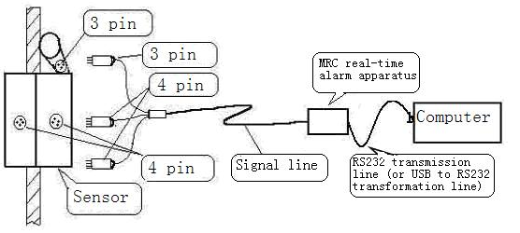
Picture 2 Signal Sampling Wiring Diagram
- Juxtapose the sensor on the wire rope which needs to be tested.
- Insert the signal line three cores plug into the sensor encoder three cores jack, four cores plug into the upper and lower sensor body of 4 cores jack (no distinction between upper and lower plugs), and tightened to prevent testing process shedding.
- Connect the signal line another end to the MRC real-time alarm apparatus (power source disposition), again use the RS232 lines (or USB to the RS232 transmission line) connect with the computer.
- The system has been connected, and we turn on the power switch and start the computer, and then start to work.
The hardware connection finished.

4.3 Sensor Installation
The testing position choice, regarding a safe test, is an extremely important first step. Choosing the suitable installation position, it will directly affect the test smoothly going. The testing position choice should select time and address, through to wire rope detailed thorough observation, in the determined safety control situation carry out the suitable choice.
4.3.1 Sensor installation position choice
Install the sensor in the wire rope smallest swinging position. The installation must have the certain flexibility, use hangs the floating type to be fixed, avoid the wire rope swing in the probe; Only through the sensor partial wire ropes can be tested, therefore, when testing exist Dead Zone, should choose the multi- spots testing. Far away from the heat source, the magnetism source, and other the strong effect on magnetic field instrument and so on
The testing position can choose in the wire rope overhaul place. That needs to pay attention, the testing position have to remain operation space, to guarantee the personnel and the equipment safety. The testing positions certain situation, the instrumentation stability mainly by the testing personnel to realize. When overhead testing, the testing personnel have to tie the safety belt, and to the testing instrumentation, use necessary soft connection (for instance to use nylon rope, safety belt and so on). When by operator hand-held, the testing wire rope movement speed should small 0.5 m/s (suggestion testing speeds not to be possible to surpass 1m/s).

4.3.2 The testing position mark
In the testing process it should make the needed mark, achieves completely testing. For example: starting mark, region section mark and so on.

4.3.3 Sensor installation method
Regarding the service wire rope instrument installation, he use the static installation method. Namely under the machine closing condition, install the sensor in the testing plan determined testing starting mark place, while equipment lead wire rope operating, test the wire rope section method. Matters needing attention as follows:
- When installation, should make the instrument been at the relatively stable condition;
- Do not affect the equipment the normal work;
- Use the necessary soft connection to the testing instrumentation to protect safely;
- Correct choose wire rope movement direction.

4.4 Software operation

4.4.1 Starting system
After inspecting that whether the sensor is installed appropriate and the connection condition, whether each part of joints is correct unmistakable and whether the spiral buckles are tightened unmistakably, turn on the computer power source (including data acquisition switch).
Method 1: Open "MTC windows" folder under the computer Disk C root directory, directly click on "MTCwindows.exe" the procedure file, then will open the system program.
Method 2: If there has been "MTCwindows.exe" fast way on the computer desktop, may directly click on the "MTCwindows.exe" fast icon, and then will open the system program.

4.4.2 Function significances introduction
In the system program, on top of the software, they are function options such as File, System, Settings, Operation, Report, and Help etc (See Picture 3). After clicking on the main function option, the drop-down menu options could be operated. Some parts of them also can be operated by clicking on the next row icon. When the mouse assigns and pauses in this icon several seconds, namely will appear this icon function annotation.
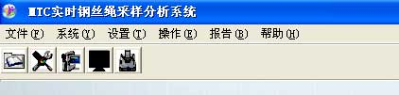
Picture 3 Main Functions Items
4.4.2.1 File
The file (Alt+F) contains opening, preservation, withdrawing three functions.
- The “open” (Ctrl+O) refers opens already saved in the disk data file to view and process. This function item has two operating modes: One kind is the browsing, namely carries on the browsing to the designation file, but does not make any analysis; One kind is the analysis, namely carries on the evaluation to the designation file (man-machine dialogue contact surface), according to the parameter logarithm which assigns according to carries on the processing analysis, and may obtain its partial flaw the report.
- The “save” (Ctrl+S) is to the file memory function, mainly refers when the data acquisition, the data preservation path and the file naming.
- The “withdrawing” (Alt+F, X) refers to the withdrawal system, end the entire operating system.
4.4.2.2 System
The system (Alt+Y) in the item contains the sampling parameter, ports choice function.
- The “sampling parameter” (Ctrl+G) is the real-time sampling data parameter to the system. This item contains two parameter items: Noise threshold value, wave magnification rate (As Picture 4). Noise threshold value is when a sampling appears the disturbance pulse signal. This value is rejecting this kind of unwanted signal to suppose the definite value. When the neighboring three digital composition wave forms surpass this value, computer makes sure it is the disturbance, and automatically removed. Generally set between 100 and 1000, mainly rely on in the use process the disturbance signal to
certain; The wave magnification rate is when gathers the data signal, the window demonstration wave extent magnification, its value is the real value, may willfully input, appropriately as is mainly suitable take the user, generally supposes is 3 ~ 10. | 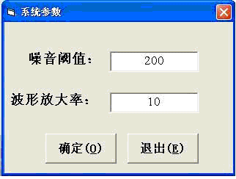  Picture 4 System Parameter
- The “port choosing” (Ctrl+C) is the used serial ports (COM1, 2, 3... ...) when the system samples signal. Only filling with the port number in this column is OK (As Picture 5). If use the port COM2, fill 2 in the blank space, each time use the same port, then do not need to input each time; When use USB to RS232 transformation line, if each time insert the same USB port, then only need input once. Because when use USB to the RS232 transformation line, the computer has many
USB ports, must have to clearly recognize the port number, and input the correct number and press the definite button then. | 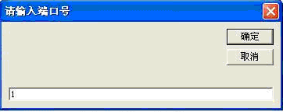  Picture 5 Port Setting
Note: The port number recognition can be searched from the computer, when only has the input correct port, the system can work normally. Concrete method step as follows:
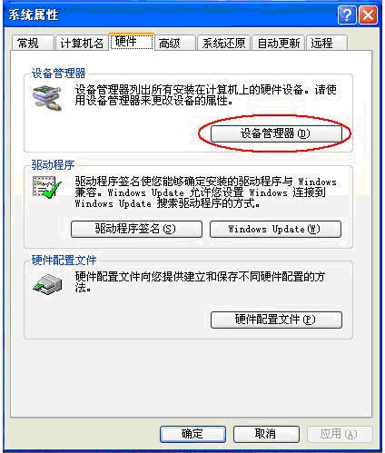
Picture 6Computer Attribute Picture
The Mouse designates desktop my computer (or "start"), and click with your right mouse button on the "attribute", bouncing my computer attribute window (See Picture 6).
- Click on the attribute window hardware item, the appeared interface has the equipment management item.  - Click on the equipment management, the appeared interface has a port item, and directly click on port item in front of "+", immediately appear the expansion menu, may view the present connection port number (See Picture 7), remember and input in the port choice item. | 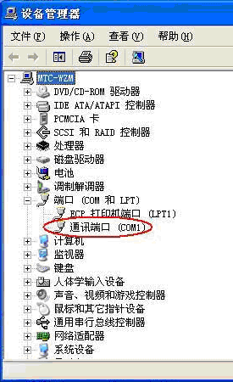  Picture 7 Port Number
4.4.2.3 Settings
4.4.2.3.1 Function introduction
The settings item (Alt+T) contains the "add parameter", "amend parameter", "delete parameter", "select parameter" four functions items. Mainly to parameter different operation function item (See in Picture 8).
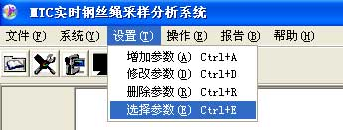
Picture 8 Parameter Settings
- The "add parameter" (Ctrl+A), in existing parameters, there is not the suitable parameter, need to add new parameter, use this function item.
- The "amend parameter" (Ctrl+D), in existing parameters, there is roughly suitable parameter, there still be inappropriate one to several small items, slight adjustment then could to be used, this time may use this function item to the parameter which need adjust slightly. When choosing this item, may carry on multi-group parameters revision adjustment, revise to each group parameter, press OK button to confirm. Finally press the exit button to end and exit.
- The "delete parameter" (Ctrl+R), in existing parameters, there is unnecessary or false parameter, it will be no longer to be used, may use this function item. The selection needs to delete Parameter Group, click on OK button to confirm deleting. If this parameter is being used, then it cannot be deleted.
- The "select parameter" (Ctrl+E) is that, in existing parameter to select this operation needing to use Parameter Group. After choosing this function item, click on “serial number” lower right drop-down button, in the drop-down window, select a group of parameter to suit this operation, press determination button to confirm and exit.
4.4.2.3.2 Definition of the Parameter
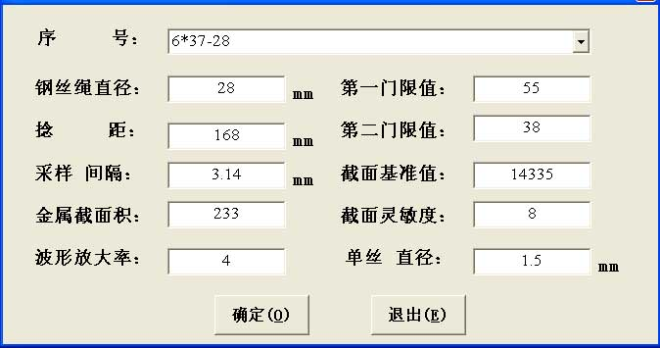
Picture 9 Parameter settings
In parameter item, each small item has the different meanings, now will introduce one by one:
Parameter Order Number
The parameter name and information, which this software sets and saves, it will be selected according to different testing wire ropes. Settings can name according to the wire ropes specification information, convenient to search and recognize.
The diameter of wire ropes
The nominal diameter that is tested wire rope unit is mm.
Lay pitch
The testing wire rope length in one lay pitch. The unit is mm. This parameter is in the light of the software automatic scan and accumulative total with in broken wire quantity summation. When discard standard of wire ropes don’t calculate for broken wire quantity within lay pitch can input stipulate length according to requirement.
Sampling interval
When the guide roller of location measuring appliance is rolling on the wire ropes, whenever photoelectric encoder send out an impulse, the guide roller rolled distance of travel. Unit is mm. It is decided with the diameter of guide roller, definition of photoelectric encoder. Print the sampling Interval size of these appliances on every location-measuring appliance. Parameter installation can be contrasted proceeding.
The metallic cross-sectional areas
The wire rope testing is all the wire rope cross-sectional area total in hew wire ropes. The unit is mm². These are check in operating instruction manual for wire ropes, or obtain on the basis of structure calculation for wire ropes, pay more attention to the same diameter the different structure for wire ropes. Their metallic cross-sectional area totals are different. For this reason, the same diameter, the different structure for the wire ropes must be set two groups of different parameter. The metallic cross-sectional area size is on the basis of calculating loss rate (increase or decrease) of the metallic cross-sectional area. Have to correct input.
The first threshold value
The threshold value of the qualitative installation in the unusual signal is caused by obtainment partial flaw (for example broken wire), is parameter that software automatic scan to test signal data, It ascertain with instrument calibration to each kind of wire rope.
The second threshold value
Judge partial flaw extent (such as broken wire numbers) the threshold value of quantitative installation. The software will be based on the value to determining imperfection to calculate. It ascertain with instrument calibration to each kind of wire rope.
Magnification rate of wave form
Test signal wave scope proportion is used into reduces or the enlargement when the partial flaw evaluation. Its value is the real number value. The more for magnification rate of wave form, the more for showing signal wave form amplitude, otherwise is less, when different specifications wire ropes are tested, regulation value make wave form limpid and vivid on the screen show.
Reference Value of Cross-sectional Areas
When new wire ropes detect, software measure acquire LMAO value. That is to say, the metallic cross-sectional area is corresponding with LMAO value at new wire ropes. It mainly is the reference standard value when calculate the metallic cross-sectional area changing. The value ascertainment is description in the parameter calibration.
The sensitivity of the cross-sectional area
The metallic cross-sectional area of the unit square millimeter is corresponding with the changing quantity of the test signal value. It is the function parameter of senor. There is a discrepancy in the sensor for different specification and structure. It also ascertain with calibration of instrument.
Single wire diameter
It is a single wire diameter of the testing wire rope. Generally choose the wire rope outer thick wire diameter.
4.4.2.4 Operation
The operation (Alt+E) item contains the sampling, broken wire analysis, and deterioration analysis three functions items, is this system main partial. The sampling control and processing analysis functions to testing wire rope primary signal will be introduced one by one.
4.4.2.4.1 Sampling
The sampling (Ctrl+M) is the signal sampling control and real-time display function item to the testing wire rope. Click on "the operation" drop-down window "the sampling", then arrive the sampling main window (the following picture); Or use fast key way to open according to the software prompt; Also may use the tool column icon, clicking on the icon could directly open the sampling window.
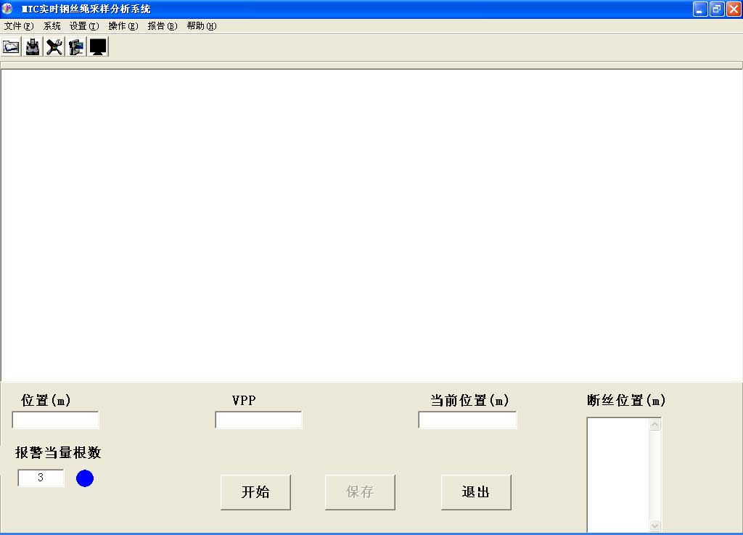
Picture 10 Sampling Main Window Picture
The sampling window screen display introduction:
    - The interface first line is the main function operation;
    - The second line is the frequently-used tool column;
    - Lower blank window is the sampling real-time display signal window, when sampling, all signals data can the continual display in this window.
    - There are five small windows under the display window; they are position, VPP, current position, broken wire position, alerting the equivalent number. The position is display window forefront starting position when sampling, namely length before this screen testing, unit is m; VPP is this place partial flaw (for example broken wire) conversion electrical signal value when auto-alarm to the partial flaw (for example broken wire) according to selective parameter in sampling; The current position is sampling wave display position, namely this test total length, the unit is m; Broken wire position is the position record that the system automatically distinguish and alert to the partial flaw when testing; Alerting the equivalent number is a threshold value that the system send out the warning to the partial flaw (for example broken wire) when this testing, the system default setting is 3, may voluntarily to revise according to need, when the system test and distinguish this place flaw degree quantification to attain this number, the side blue lamp changes red, at the same time, in broken wire position window records the displacement length form here to testing starting position.
    - On the bottom of the main window there are three buttons: “Start”, “Save” and “Exit”. “Start” is the sampling instruction button that is clicked to start testing operation; “Save” is conclusion sampling instruction button that is clicked to end testing, clicking on this button is to finish this sampling and to save the test data, so a preserved data default folder will pop, revise the preserved way according to requirement; “Exit” is the instruction button that is clicked to withdraw from the sampling window, when the sampling, if this button to be clicked on, it will finish this sampling operation and withdraw from the sampling window, the test data will be not preserved.
Sampling concrete operation procedure as follows:
    - If it is the first time to sample or change for the input port, it need input this sampling communication port (RS232) serial number and preserve.
    - Choose a group of parameter to suit this testing wire rope and confirm. If there is not the usable parameter in existing saved parameters, may add or mend a group of more appropriate parameters, and reselect to confirm.
    - If there is relative displacement between the testing wire rope and sensor, click on "Start" button. Then the sampling will start, and sampling data signal wave will appear in the display window.
    - When testing finishes, click on "Save" button, end sampling and save test data. According to the popped “Save” window may save with the needed route (default route C:\mtcwindows\Data\) and naming way. If this data is unnecessary also to be allowed to click on “cancel” button to not save.
    - Data collection process is possible to operate more times. Collections again, save the data with new name.
    - After the sampling finishes, may the click on “Exit” button to quit it and enter other operating procedures, or may directly enter the man-machine dialogue procedure for the current sampling data.
    - After the current sampling data preservation, click on operating column "broken wire analysis" item (or directly use fast way key), or directly click on tool column "broken wire analysis" button which the all can enter just saved file flaw analysis.
4.4.2.4.2 Broken wire analysis
Broken wire analysis (Ctrl+N) is the man-machine dialogue procedure, is the analysis processing function item for the test data. Two methods can enter this procedure: One is directly entering the human body dialogue according to preceding; Another is "open" way to enter, click on operating column "broken wire analysis" item (or click on tool column icon button) to enter the operating sequence, or click on “file" column "open" item, the inquiry window will pop, click on "analysis" item to enter the operating sequence.
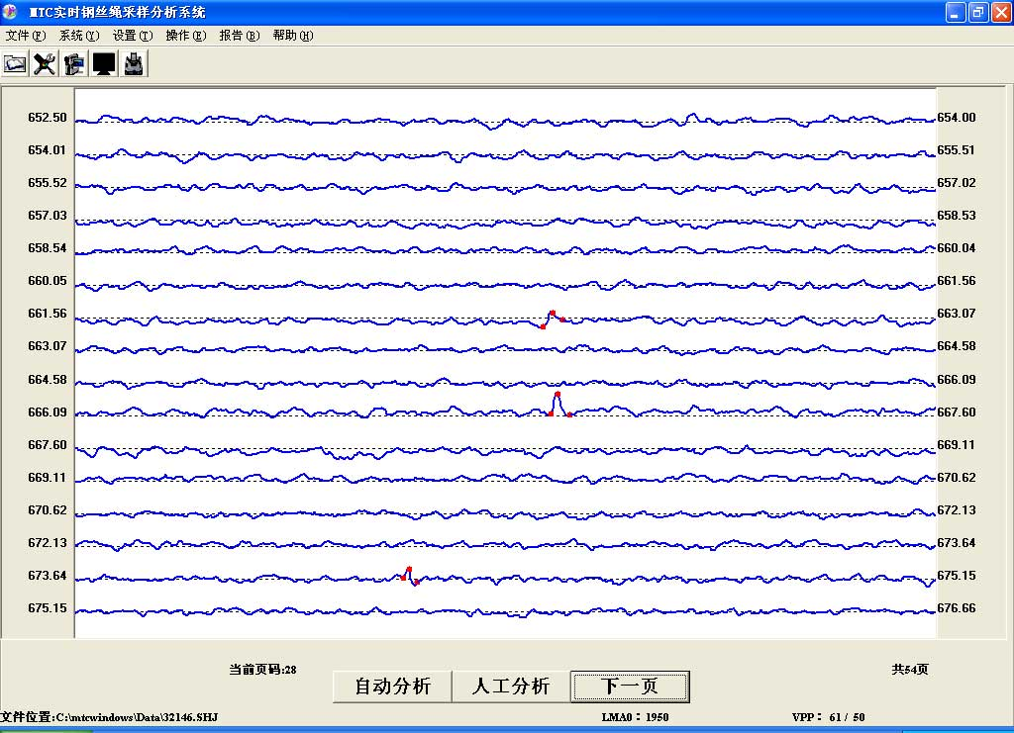
Picture 11 Broken Wire Analysis Interface Picture
Broken wire analysis (man-machine dialogue) the surface introduction that:
- In the procedure window, center is the data wave form display picture, a screen altogether displays 16 lines, and each line altogether displays 512 sampling spots.
- Display window two sides numerals are both distance display: Left is this wave form corresponding testing starting location; Right is total this wave form corresponding testing displacement between the starting and ending location.
- Two page numbers under the display window: One is the total page number; the other is the current page number.
- There are several buttons in the middle of the two page numbers, when the total page number is not more than 1, there are two buttons, “Analyze automatic” and “Analyze artificial”, when the total page number is over 1, there will add one: “Next”. Click on “Analyze automatic”, the system will judge the red marked spot and calculate each partial flaw result according parameter that select (for example broken wire equivalent number or proportion of cross-sectional area to total cross-sectional area); Click on “Analyze artificial”, the system will mark all suspicious wave signal points, the points will be confirmed or removed by the experienced operator, the system will write up report according to judgment result. The two operations will only be aimed at the current page, must reselect operating mode after the page turning. “Next” mainly is used in turning the page, will only be able to turn one page to next page, the earlier pages will be not able to view before judging ending. Dragging the roll to scan the earlier pages will be allowed only after judging ending, but amending is not allowed.
- There a row display below the buttons, left side is the route and name of the file opened this time; the middle is the LMA0 value, this value is the reference value of cross-sectional areas automatically calculated by the system for this group of data, is on basis of the first row average of this data wave form. In calibrating process it just need to fill in cross-sectional area parameter column, the system will evaluate processing analyzing data the metallic cross-sectional area changing (for example deterioration) according the LMA0 value.
- When use artificial analysis, a group of VPP value appears in right and bottom, namely former crest to crest value and latter crest to crest value of this wave form partial abnormity signal in the location marked in red spot in display window. When use the automatic analysis, this value will not appear.
Broken wire analysis procedure as follows:
- Select a group of parameter to suit this evaluation, if there is no suitable one to be possible to add or amend, and confirm the selection to use.
- Enter the procedure according to the above operating procedure, a “Select data file” window will pop, and click on prepared analyzing processing data file, open to enter the procedure item.
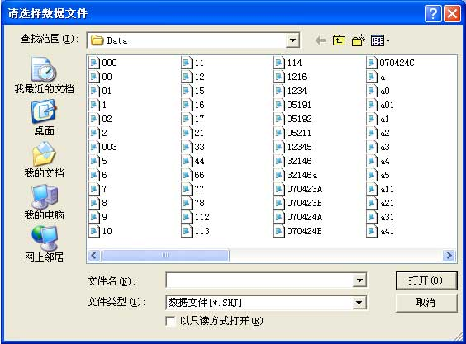
Picture 12 Data Selection File Window
- The system will act according to the parameter logarithm which will elect according to carry on the automatic scan, when the partial flaw signal two crests values mean value will be bigger than first threshold value, will carry on the sign note to this place, and will give the sign note to this page all similar situations.
- Each point will be confirmed or removed by the experienced operator, and the slack strand, jumping wire, deformation and other flaws of the wire rope may be judged from the testing wave form. Pay attention to isosceles triangle whose two crests values the data difference is not big, and wave form crest is similar to acute angle. The concrete flaw characteristic and the evaluation detailed knowledge may be seen in the chapter 6, the flaws analysis and the evaluation.
- When the operator has no different opinion on the marked red spots in current page screen, and judge them broken wire, directly click on "Analyze automatic" button. All the marked red spots in this page will be confirmed for broken wire, the system will automatic calculate quantification value in each place, and display the value list in the result report. Click on "Next" button to turn page and operate again.
- When the operator has different opinion according to flaw signal on part of the marked red spots in current page screen, must reject the part, and will have to use artificial analysis evaluation procedure. Directly click on "Analyze automatic" button to enter the artificial analysis procedure. All red spot mark will be scanned one by one in the current page, when scanning to some a spot, the mark color will turn black, and its VPP will appear in right below, and a dialogue window will pop and inquire whether this mark is broken wire. If judge it broken wire, click on "Yes" in the window, and the marked spot will assume red; If it is not, reject it, then click on "No", the marked spot will assume yellow. Also may use the fast key to judge that, if confirm, press "Y" (or press the “Enter” key), if deny, press "N". When need continuously confirmation or denying, long press "Y" (press the “Enter” key) or "N" continuously similarly judge.
- When the operator has different opinion according to flaw signal on all the marked red spots in current page screen, all will give them all denying, long press "N" key. When this group of data have the multi- pages screen, may directly click on the next page to give the full page denying and to enter the next page of screen, so all the marked in this page will be denied, and no longer enter in the judging result, but last the page cannot so, only be able to long press "Y" or "N" according to the above method.
- After each page analysis ending, two buttons assume excessiveness.
- If the result report needs to be analyzed and evaluated this time, must when the analysis evaluation ends, immediately enter report column and click “broken wire report” item, open and view the result report.
- After assigning out data file, may continue to reselect data file that need analysis.
4.4.2.4.3 Deterioration analysis
The deterioration analysis (Ctrl+L) is evaluation procedure to the testing wire rope metallic cross-sectional area change (for example deterioration), is an automatic evaluation function item for the test data according to a datum value. Click on “Deterioration analysis” in operating column (or direct use fast key) to enter the operation sequence (As Picture 13).
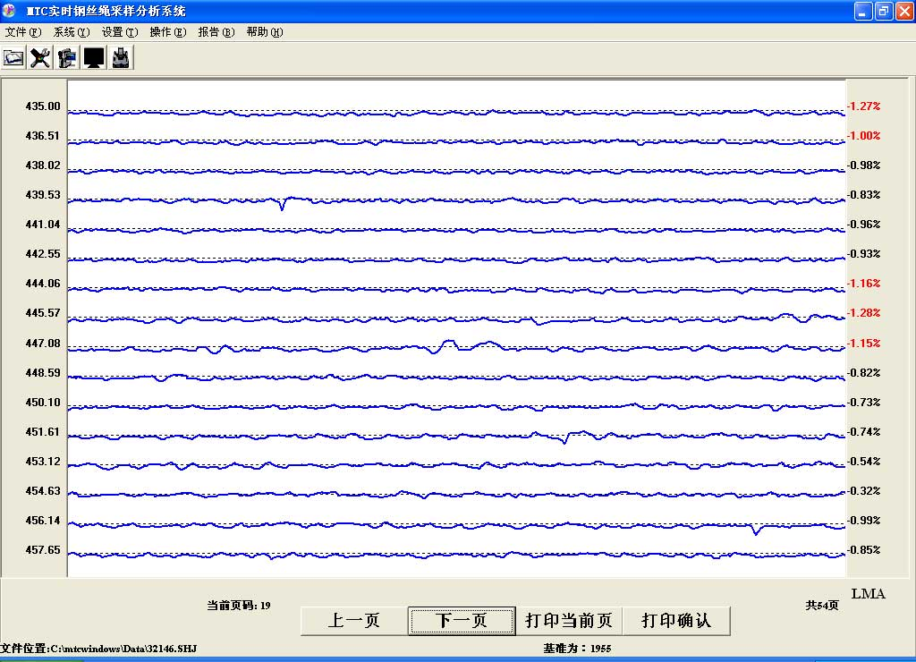
Picture 13 Deterioration Analysis Interface Picture
Deterioration analysis interface introduction:
- When enter the procedure, a “deterioration warning threshold” window will pop (like Picture 14), input a positive number in the blank space according to each profession standard specification limiting value, or according to one’s own requirement. The procedure will rest on this value will calibrate the result according to metallic cross-sectional area reduce (for example deterioration). When the result surpasses this value, color of deterioration percentage in right surface will turn red. The wave form data result that assumes red will be recorded in the deterioration report.
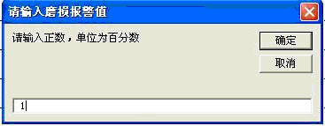
Picture 14 Data Selection File Window
- In the procedure window, center is the data wave form display picture, a screen altogether displays 16 lines, and each line altogether displays 512 sampling spots.
- Display window two sides numerals are both distance display: Left is this wave form corresponding testing starting location; Right is the increasing or decreasing percentage of this wave form corresponding the metallic cross-sectional area datum value, namely LMA change percentage.
- There are several buttons in the middle of the two page numbers, when the total page number is not more than 1, there are two buttons, “Print current page” and “Printing OK”, when the total page number is over 1, there will add two: “Back” and “Next”. “Print current page” is that, regarding the current page graph, click on "the printing current page" button, regarding each current page in requirement, may click on this button; “Enter” is the button to confirm to print the page in requirement. Each A4 paper may print two screens, may print all the pages in waiting in turns. When just one screen need to be printed, may click on “Print current page” first, and click on “Enter”, the current page will be printed immediately. “Back” and “Next” is the function buttons that used in turning page.
- There a row display below the buttons, left side is the route and name of the file opened this time; in the middle it displays the cross-sectional area datum value, the system will evaluate processing analyzing data the metallic cross-sectional area changing (for example deterioration) according this value.
Deterioration analysis concrete sequence of operation as follows:
- Click on "Deterioration analysis" in operating column, "deterioration warning threshold" window will pop, according to one own requirement or each profession standard, input with a value in the blank space, and confirm.
- After inputting the parameter, a primary data folder will pop. Select the file that needs to be analyzed and open it.
- The surface will display this file data wave form, and display each position section corresponding metallic cross-sectional area changing. If the metallic cross-sectional area changing surpasses the supposing value, the number in right surface turn red reports to warn, this section corresponding wave form spot position, the conclusion position and the greatest value of this section reduction will be recorded in the report.
- Regarding each current page in requirement, may click on “Print current page”，When all the pages in requirement are selected, click on “Printing OK” and enter the printing procedure.
Attention: When click on the printing, in advance connect the printer and the computer, and set the printer which connects as default printer.
4.4.2.5 Report
The “Report” (Alt+B) contains broken wire report and deterioration report two function items, these two items are the display for analysis result.
4.4.2.5.1 Broken wire report
The "Broken wire report" (Ctrl+P) is the display for the primary data analysis result in the man-machine dialogue procedure, and is saved as the Word format.
Concrete operation as follows:
- When all analysis evaluation (man-machine dialogue) to some primary data “Broken wire analysis” procedure is finished, click on "Broken wire report" in report column.
- When open the report, a report format setting window will pop, and l set the report format selection (As Picture 15). This window contains two major terms: “File Selection” and “Result Option”. The “File Selection” contains “earlier result” and “newer result” two options, selecting “earlier result” means opening the analysis result at the time of the testing sampling , and selecting “newer result” means opening the current analysis result. “Result option” has “broken wire equivalent number” and “cross section percentage” two options, selecting “broken wire equivalent number” namely display the equivalent number of broken wires in broken wire report, and selecting “cross section percentage” namely display the percentage between cross section and the total sectional area in broken wire report. Just click on the circle in front of the choice, and confirm.
- After completing the choice and confirming, open the needed report immediately.
- This report might be saved in needed file according to the Word operating mode.
Attention: In broken wire analysis procedure, the broken wire report could be opened only after finishing all analysis in the page.
Broken wire report format introduction (As Picture 16): In the report crest it is the report name and category and the analysis evaluation time, under that it is the testing wire rope length, the wire rope diameter, the wire rope lay pitch, the testing wire rope length is testing wire rope total length. The below broken wire list, contains the serial number, broken wire position (m), broken wire number (root), accumulative total broken wire number in lay pitch (root). This report displays the localization, quantitative result, where broken wire is, and how many broken wire. When by percentage, report displays the serial number, broken wire position (m), and the cross-sectional area percentage (%).
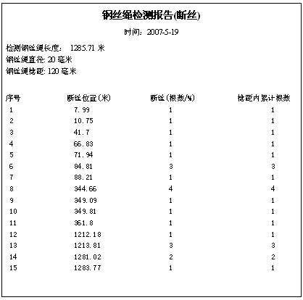 | Picture 16 Broken wire report
4.4.2.5.2 Deterioration report
The "Deterioration report" (Ctrl+T) is for display for the primary data analysis result according to the cross-sectional area datum value, and is saved as the Word format.
Concrete operation as follows:
- When all analysis evaluation (man-machine dialogue) to some primary data “Deterioration analysis” procedure is finished, click on "Deterioration report" in report column.
- This report might be saved in needed file according to the Word operating mode.
Attention: In the deterioration analysis procedure, report item can be opened only after browsing all pages, and the report only at this time is the complete analysis evaluation report.
Deterioration report format introduction (As Picture 17): In the report crest it is the report name and category and the analysis evaluation time, under that it is the testing wire rope length, the wire rope diameter, the wire rope lay pitch. The below deterioration list, contains the serial number, the starting position (m), the ending position (m), deterioration quantity (%).This report displays the starting and ending points that each section of deterioration surpass the suppose value, and juxtaposes this section biggest deterioration quantity. If there are the continual deterioration surpassing the limit, it will display by list, and display where the deterioration is, how much deterioration quantity.
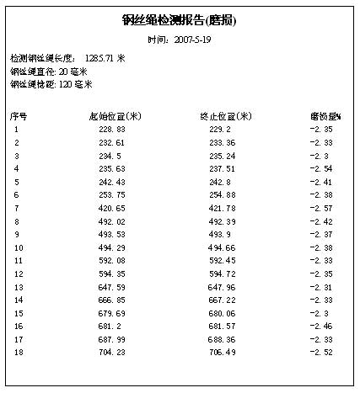 | Picture 17 Deterioration report Display
4.4.2.6 Help
The “Help” (Alt+H) function item is help material that the system uses. Click on operating instruction in the drop-down window then to open the system software “service manual” (Ctrl+F). It is suggested that try to know well the system software service manual and the MTC wire rope computer detector instructions for using, and grasp some elementary knowledge such as the instrument installation, working instruction and data signal processing analysis etc before use.
4.5 System Operation Flow
The system operation is on the principle of step-by-step, should be on the basis of familiar with the system. Only Grasping the instrument hardware connection and the installation elementary knowledge, familiar software method of application, can test and sample data; When data signal flaw analysis evaluation, it must be operated or directed by the experienced operator or the personnel who has the qualified qualifications after training. Concrete operation flow like Picture 18 shows:
Examine the instrument
Install and connect instrument
Open each part power supply
Start system software
Sample the data
Analyze and evaluate data
Print result and diagnosis report
Picture 18 Operation flow Picture

5. Parameter Setting and Calibration
Want to correctly use the wire rope computer detector, understanding the testing parameter significance and how to set the parameter first is the key. After the MTC security testing instrument finish signal sampling to testing object, flaw analysis software in computer will analyze and process the sampling data on the basis of the setting parameter. If the parameter setting is unreasonable, it will cause the wire rope flaw quantitative judgment error, and affect the wire rope the flaw testing precision.
Using the MTC wire rope security testing instrument, it is necessary to set 11 parameters, among that, the serial number, the diameter, the metallic cross-sectional area, the lay pitch, the sampling interval, the wave form reduce rate, and the cross-sectional area sensitivity can be obtained through looking up the data list, the computation, or technical data that the merchant provides. Most essential is the first threshold, the second threshold and the cross-sectional area datum value setting.

5.1 Serial Number Setting
This serial number column mainly is used for different parameter naming, in order to memory and search. It generally suggested that the user name it by the wire rope model specification and diameter, moreover also may increase some distinctive marks in this foundation, but cannot make the entire name be redundant. For example the wire rope that its diameter is 20mm, and its specification is 6×19S+FC, the naming is 6*19S+FC-20 (may increase any distinctive mark behind).

5.2 Diameter and Metallic Cross-sectional Area Setting
If testing some a wire rope flaw not only must know the wire rope diameter, moreover must understand the wire rope the structure. But due to adapt to the needs of different industries, changes in the structure of many rope, even if the wire ropes have the same diameter, their metallic cross-sectional area may be different. For example: Diameter with for 25mm wire ropes, the 6×WS(36)＋IWRC wire rope metallic cross-sectional area is 319 mm², the 6×Fi(25)＋IWRC metallic cross-sectional area is 311 mm², the area phase difference rate reaches 3%, moreover the wire rope also has wire rope core and fiber rope core different. Therefore, in metallic cross-sectional area parameter setting it must make every effort correctly. This parameter can be obtained through looking up the data list or actual calculation.
5.3 Lay pitch Setting
The wire rope lay pitch is that a jet of wire rope around the rope core one circle straight distance. Extending development has been made in the MTC wire rope testing instrument, for testing the wire rope respective broken wire total number in the correlation length, how to test this length is different in different profession; it need accord the standard that is carried out. For example: when Shanghai Construction test hoist crane, the setting related length is 6×d (d is wire rope diameter)
5.4 Sampling Interval Setting
The MTC wire rope security testing instrument signal uses equal space sampling. This parameter setting is according to distance locator guide roller in the sensor revolving a round and computer sampling 100, namely guide roller perimeter 1% for equipment sampling interval. Then, it is expressed by the followed formula:
Sampling Interval (mm) =Guide roller Perimeter (mm) ÷100

5.5 Broken Wire Parameter Calibration

5.5.1 Broken wire number judging method
Testing software judges broken wire according to the following process. First, seek local anomaly signal in several hundred meters test signals (usually produced by broken wire); After found the signal which the fracture produces, this position broken wire number is obtained through the software computation, thus obtain broken wire position and broken wire number, broken wire position should be determined to space between jet, different broken wire out of a jet along the rope axial will be identified as different broken wire location, namely broken wire resolution is space between jet.
Saying from the signal processing method, the testing software that completes above operation is realized by using setting threshold. When there is signal more than First Threshold value in the test signal is the partial flaw, the First Threshold value mainly is broken wire recognition qualitative parameter, whether there is broken wire, if its value is too small, it will possibly appear judging more; Oversized will possibly appear leaking testing. The Second Threshold value is signal quantitative distinction parameter in that surpasses the First Threshold value, its size is mainly decided by the simple wire rope diameter, if its value is too big, the broken wire number will be judged less; too small, broken wire will be judged more.
Correctly setting “first Threshold value”, “second Threshold value” is the key to judge and analyze the test signal unmistakably. Therefore how to set “first Threshold value”, “second Threshold value”, the concrete method has two kinds: One is off-line calibration (most basic, most normative) and the other is on-line calibration.

5.5.2 Off-line calibration method
Take a new or old wire rope, which is same as the testing wire rope and its length not smaller than 2 meter, as the experiment. Put up and tense this wire rope, then simulate the standard broken wire, generally simulate one, two, three and several concentrate broken wire, test with the instrument. The concrete request may refer to American ASTM E1571-1996"Electromagnetic Method Testing Wire rope Standard Rule".
Like Picture 19 shows:
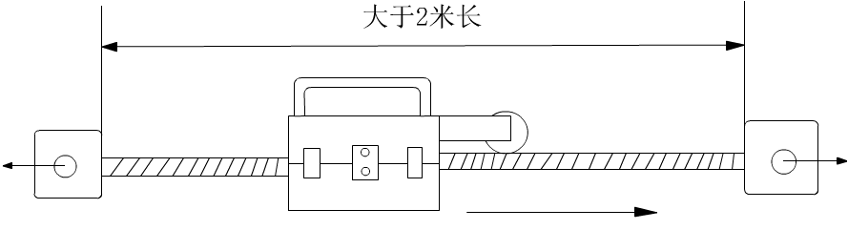
Picture 19 Calibration wire rope installation diagram
Install the detector set, set the known wire rope parameter in the "add parameter" function, like the diameter, the metallic cross-sectional area, the lay pitch, the sampling interval, the magnification rate of wave form (temporarily suppose may be 1), and set "First Threshold value" and "Second Threshold value" as smaller value. Enter "select parameter" function to select this parameter serial number. Enter the "sampling" function, draw the sensor to pass through the simulation broken wire position (to be possible back and forth movement), end testing, enter the analysis procedure.
Screen display testing wave form. When "First Threshold value" is bigger, the correspondence broken wire the signal will not be able to instruct that, now should return to calibration "First Threshold value" to change slightly, and then enter "Broken wire analysis". Assign out the test data filename, enter broken wire artificial analysis, and operate like following.
Broken wire recognition process, the software compares each crest signal, when it surpasses "First Threshold value", will mark it with three red spots. If it is not broken wire correspondence signal, then find next crest spot that surpass "First Threshold value", continue to operate until completing all broken wire signal marking.
Observe the group of values under the screen; the two values after the VPP are respectively the crest value. Set "First Threshold value" as about 85% of the smaller in two crest values. If "First Threshold value" is too small, non-broken wires signal will be marked. Observe the value above the screen, and broken wire signal amplitude changing between the background signals will be found, and "First Threshold value" will be set appropriately. Because the concentrate broken wires are 2, 3 or more, its corresponding signal amplitude is bigger than it corresponding 1. "First Threshold value" setting aims mainly at single broken wire.
After the "First Threshold value" setting, enter the historical data to judge broken wire, for the red marked signal spot, press the "Enter" to confirm, after the operation finishing, observe the testing result display, adjust the "Second Threshold value", make the testing result basically consistent with the broken wire. Set parameter and test continuously to obtain the best value.
Regarding wire rope which is composed by the many kinds of specifications wire rope, when judging broken wire must select suitable "Second Threshold value" to get the reasonable comparable quantitative result and the calculation result is displayed as the equivalent number at this time. When the wire rope rust is serious, the rust spot also will produce a bigger local anomaly signal, thus it would be possible to judge as broken wire signal.
5.5.2.1 How to set "First Threshold value"
On the computer man-machine dialogue surface, set "First Threshold value" with the purpose of marking the sampling data having one more broken wire with red spot for user distinguishing. If setting "First Threshold value" too big, then many broken wire flaw will be missed. Otherwise, the "First Threshold value" is too small, and then many normal (non-flaw) sampling on the wire rope also would be marked by the red spot, make the unnecessary trouble for the operator.
In order not to let broken wire flaw leave out, the "First Threshold value" should be slightly smaller than leakage magnetic signal computer outputting. Take Picture 20 for example, from compared experimental test data, we analyze according to the known broken wire position, broken wire spot "P" has one broken wire, the leakage magnetic signal computer outputting (VPP) respectively is 75 and 60, if the "First Threshold value" setting is bigger than 75, then broken wire spot "P" will not be marked, form leaking judgment. Therefore the "First Threshold value" should be slightly smaller than 60, usually, we set the D1 as about 85% of 60, it is 51 (the note: VPP is taken to broken wire place leakage magnetic computer outputting, and is usually taken a the smaller).
It is expressed by the followed formula:
First Threshold value=VPP×85%
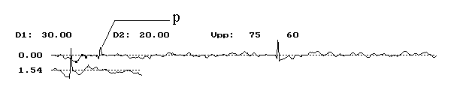
Picture 20
5.5.2.2 How to set "Second Threshold value"
We test the wire rope broken wire with the purpose of quantitative judging. In the man-machine dialogue surface, the wire rope broken wire is initially recognized by "First Threshold value" and the operator confirms, broken wire position has been settled. And the broken wire quantitative duty will be completed by flaw analysis software. The broken wire quantitative error is decided by the "Second Threshold value" setting level.
It is well known, wire rope application is widespread, along with various professions operation requirement, various kinds of specification wire rope come out, and moreover the diameter specification changing is many. Big to more than 200mm bridge cables, slight to several mm logging wire ropes, they are all needed to test broken wire and the deterioration with the wire rope security testing instrument. One broken wire, because the structure, the rope diameter and the wire diameter are different and the broken wire form also are different, the broken wire leakage magnetic outputting is also different. If "Second Threshold value" setting dose not change along with it, then, the broken wire quantitative error will be very big. In other words, the structure is different, the rope diameter is different, "Second Threshold value" setting also should change along with it.
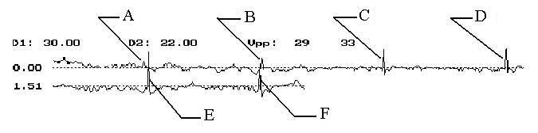
Picture 21
Therefore under premising condition, it should be better to first take one section same new wire rope and make some broken wire on it before testing some one wire rope, take the section as "Second Threshold value" calibration type rope. For example, in Picture 21, the expression is 2.5m length (6×37＋IWSC) wire rope, A, B,C, D, E, F is the artificial setting broken wire spots, the broken wire respectively are 1, 2, 4, 5, 7, 6 (Generally broken wire spot is made with three, broken wire respectively are 1, 2, 3). Set willfully the "Second Threshold value" first, similar to operation testing in Section 5.2.2, if each spot error (Each place concentrate broken wire premising having ±1 root or ±1 equivalent root error) between testing broken wire number and actual broken wire number is in the technical specification permission scope, then may think the "Second Threshold value" setting conform to the requirement. Otherwise, then must reset "Second Threshold value". If testing broken wire number is bigger than actual broken wire number, the "Second Threshold value" must be brought up; the testing broken wire number is smaller than actual broken wire number, then "Second Threshold value" must be reduced. If needed, may adjust repeatedly until the error between testing broken wire number and actual broken wire number is in the technical specification permission scope. To this, we thought the "Second Threshold value" setting already completed.

5.5.3 "First Threshold" and "Second Threshold" on-line calibration
Regarding the service wire rope that has had broken wire, find broken wire position, install the sensor, move the sensor to test a group of signals, and operate like Section 5.5.2.1, get the "First Threshold Value".
Set the "Second Threshold value" as the same as the "First Threshold value", make the entire journey testing, if the judgment is 2 or more roots broken wire, find this position, and test to confirm the "Second Threshold value".

5.6 Wave Form Reduce Rate Setting
The "wave form reduce rate" is the testing magnification rate of wave form or reduce, in order to the testing direct-viewing judgment convenience, usually set it as 4~6. The bigger the number is, the smaller the wave form. Otherwise, the wave form is bigger.

5.7 Related Deterioration Parameters Calibration (LMA)
The wire rope deterioration (metallic cross-sectional area changing) main parameter are the metallic cross-sectional area, the cross-sectional sensitivity and the cross-sectional datum value, how to correctly set this parameter, will directly affect the instrument computation accuracy on the wire rope deterioration.
5.7.1 Cross-sectional sensitivity setting (on-line and off-line)
The cross-sectional sensitivity is the computer outputting variance which the wire rope unit cross-sectional area changing causes. Because many factors such as the component performance discreteness and the sensor production technology etc, cross-sectional sensitivity of every sensor are various, this parameter calibration is given by the factory.
5.7.1.1 Cross-sectional sensitivity on-line calibration
Install the sensor on the service wire rope, choose correspondence parameter serial number, enter the on-line testing, let the sensor be motionless, round the guide roller more than 6 circles(equal with sensor moving above 1m), end the testing, enter the wave form analysis, at this time on the screen there are possibly only datum line (dashed line)but no signal wave form, this mainly caused by the unsuitable cross-sectional area datum setting, and is not important, so long as pay attention to LMAO upper left screen, record it as Manrope; Turn on the sensor to clamp a wire whose material is same as wire rope in among, as Picture 22 shows, suppose cross-sectional area as Awire, install the wire and the wire rope together in the sensor, test again according to the spoken of earlier, get another LMAO, record it as Matest. Then the cross-sectional sensitivity α is defined by:
α= (Matest - MArope)/Awire
Duplicate several times of above operations; remove the operating or accidental error, desire average to obtain a more accurate α. α may be positive or negative, when the testing metallic cross-sectional area increases, the LMAO increases along with it, α is positive; Otherwise α is negative. Because of magnetic field changing, different sensor testing different specification wire rope, α size and mark can change

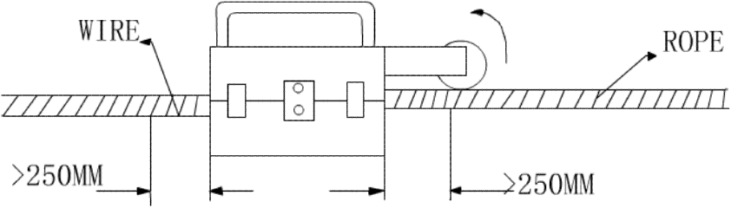
Picture 22 On-line sensitivity calibration Picture
5.7.1.2 Cross-sectional sensitivity off-line calibration
Use a section wire rope whose specification is same as the testing wire rope to measure α, install like broken wire parameter testing, what is different, the wire rope length must be bigger than 5m, install the sensor in the middle of the wire rope to remove the ends effects. As Picture 23 shows, other operations are same with on-line determination.
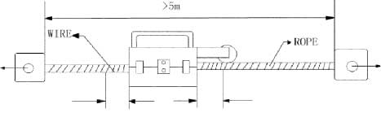
Picture 23 Off-line sensitivity calibration Picture

5.7.2 Cross-sectional datum value setting
When using the magnetism measuring technique measure wire rope metallic cross-sectional area, the sensor only can assume the linear variation in some measure scope, therefore, to some specification sensor; it only can work in wire rope cross-sectional area changes smaller scope.
Picture 24 is model outputting characteristic curve when the sensor measures metallic cross-sectional area. When want to measure some wire rope metallic cross-sectional area absolute value, must in the known some metallic cross-sectional area MAo range of linearity correspond sensor outputting signal Vo, then can through the sensor signal VT, calculate is testing wire rope metallic cross-sectional area MAROPE
MAROPE= Mao＋(VT－Vo)/α
When the MAROPE and the VT corresponding relations cannot be determined, can only determine the cross-sectional area relative variable ΔMAROPE
ΔMAROPE＋(VT－Vo)/α
Therefore, the wire rope metallic cross-sectional area measure divides into the absolute cross-sectional area measure and the relative cross-sectional area measure.
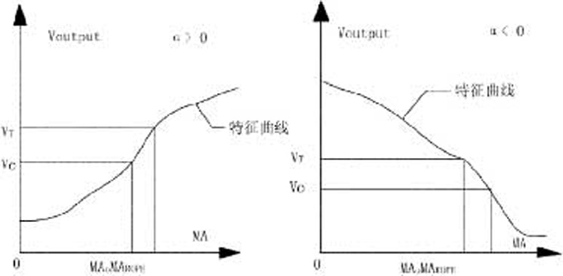 | Picture 24  Metallic cross-sectional area measuring characteristic chart
5.7.2.1 Cross-sectional datum value setting significance
If want to know the wire rope cross-sectional area deterioration, must know the wire rope cross-sectional area when it is not fray, and then can obtain the wire rope cross-sectional area relative deterioration rate. In the parameter column, after the wire rope metallic cross-sectional area inputting, the cross-sectional datum value is the metallic cross-sectional area computer outputting.
5.7.2.2 How to set the cross-sectional datum value
The cross-sectional datum value is outputted by the processing software computation. The concrete operation is as follows, may first input the free value in cross-sectional datum value column when the parameter calibration, then test the non-deterioration wire rope, in wave form analysis surface (for example Picture 25) "LMA0 = 1,949" displays LMA0 on the left, the value will be this wire rope cross-sectional datum value, input it in the cross-sectional datum value column, thus, this parameter calibration has been completed. (Attention: The first line of wave form must be orderly.)
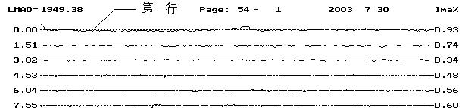 Picture 25 Testing wave form Picture
5.7.2.3 Absolute cross-sectional area measuring
Same as the cross-sectional sensitivity off-line calibration, take a section of new wire rope that is 5m long, only need move 5m in the rope central, obtain a group of test data, read the LMAO value in the wave form analysis. This LMAO value is the new wire rope metallic cross-sectional area correspondence outputting signal value. Operate repeatedly to get the average, and obtain the accurate cross-sectional area datum value.
Set this value in the testing parameter, and set the wire rope metallic cross-sectional area as the new wire rope cross-sectional area, test when the service wire rope with this bunching parameter, in the wave form analysis, may obtain each section of wire rope absolute cross-sectional area according to the cross-sectional area changing rate (LMA %) relative to the new rope.
5.7.2.4 Relative cross-sectional area measuring
When there is no new wire rope used in calibration for a while, may choose the place that had least deterioration and rust on the wire rope to regard as testing cross-sectional area datum. Because this place genuine cross-sectional area is unknown, and the metallic cross-sectional area must be the new wire rope cross-sectional area, there is some error in testing.
Usually see the 1m long wire rope from the testing starting place as parameter calibration section, this section of corresponding outputting signal is displayed in wave form analysis screen upper left, namely LMAO value. Set the cross-sectional area datum value as this value, set the metallic cross-sectional area as the new wire rope cross-sectional area, after that, all testing wire rope metallic cross-sectional area relative changing come from the comparison with this place.

6. Flaw Analysis Evaluation

6.1 Goal and Significance
In order to make the hugeness MTC series wire rope harmless flaw detector user use this product better, the company provides to hugeness users the experience that is accumulated from many years the MTC series wire rope testing instrument development, experiment, testing and the application. And take the wave form as the example, for hugeness user reference, in order to get correct diagnosis report for the wire rope.
The MTC series harmless flaw detector full name is the MTC series artificial assistance computer intelligence judgment harmless flaw detector. The so-called artificial assistance refers to the artificial broken wire, deterioration and tarnishing qualitative distinction, the computer intelligence judgment refers to the computer quantitative evaluation on the foundation of qualitative. For example: a section of wave form, operate according to the software as a matter of experience, we judge broken wire (call it artificial assistance), after the judgment finishing, the computer automatically tell us the position and number of the broken wire that we judge, the number in lay pitch (call it computer intelligence judgment).
This chapter will make the system explanation on each kind of wave forms which will meet in the real-time testing process. Analyze wave form producing reason, the wire rope material and structure influence which brings to the wave form analysis. Simultaneously we sincerely welcome the user to inform us unusual signal and the difficult problem that you meet in the practical work by sending teletext, and we analyze the reason and solute the difficulty question together.
Because of the level limiting, the mistake is unavoidable. The wire rope harmless flaw testing technology originally is a new course of study, in order to unceasingly raise our own level, earnestly hope user fix the blame with mistake in this handbook, and welcome correction, we will feel grateful.

6.2 Fire Rope Flaw
Along with period of revolution continuing, the wire rope will be able to appear each kind of damage phenomenon. For example, the wire rope deterioration and tarnishing cause wire rope cross-sectional area reducing; weary, surface hardens and tarnishing cause the wire rope interior performance changing; misapplication causes rope distortion and so on. The service wire rope possibly appears damage such as single wire breaking, corrosion, deterioration, chaotic line etc, and all damage will be able to create the wire rope breakdown. Because of the wire rope using importance and wire rope structure performance characteristic, just one place of the wire rope appears the serious flaw, the whole wire rope will be scrapped. Therefore, once the wire rope appears breakdown, it will not be repaired.

6.3 Signal Division
The MTC series wire rope testing instrument is one kind of harmless flaw testing products that base on leakage magnetic principle, therefore the signal that appears in flaw position, we may understand it as leakage magnetic signal, analyze the signal which the wire rope produces from this angle, it will not to be difficult to understand. We may divide the test signal into two kinds in general: background signal and flaw signal.

6.3.1 Background signal
This kind of signal is the "jet wave signal" that is produced by the wire rope own structure, theoretically we call it background signal. Through processing method for example difference and overlay etc among various parts test signal, and the advanced gathering magnetism technology, the MTC series testing system effectively eliminates the negative influence which the "jet wave signal" brings, and enhances the testing instrument Signal-to-Noise. The stray field in wire rope jet is a rule, cyclical distribution spatial field, therefore this kind of signal relatively even, is easy to distinguish. In addition, the "jet wave signal” reflects wire rope structure characteristic, simultaneously also reflects some condition such as the wire rope surface deterioration, tarnishing etc. We will illustrate it with some examples which have met in work.
6.3.1.1 Normal "jet wave signal":
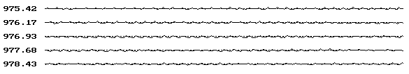Picture 27 Balance rope partial testing wave form Picture
Analyze as follows: May see from the above signal, the wire rope structure condition is good, has no broken wire, has no partial deterioration, has no tarnishing phenomenon, the structure is twisted strictly, the material quality is better.
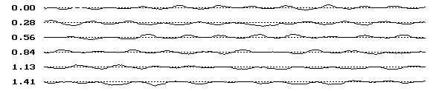Picture 28 Gantry crane partial testing wave form Picture
Analyze as follows: May see from the above signal, the wire rope structure condition is good, has no broken wire, has no partial deterioration, has no tarnishing phenomenon, but the structure is no twisted well, the material quality is better.
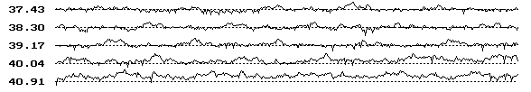Picture 29 Rope way traction rope partial testing wave form Picture
Analyze as follows: May see from the above signal, the wire rope structure condition is not good, has no broken wire, has no partial deterioration, has no tarnishing phenomenon, but the structure is twisted worse than the above two kinds, the material purity is not high, it is decided by the wire rope processing technology.
6.3.1.2 Wire Rope "jet wave signal" when deterioration phenomena:
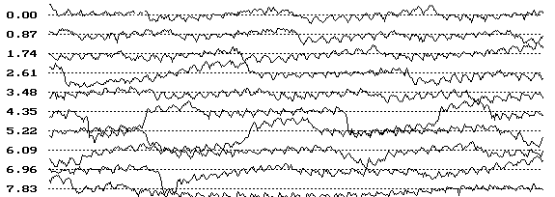Picture 30 Tower crane partial testing wave form Picture
Analyze as follows: May see from the above signal, the wire rope structure has had a bigger change in the use process, the wave form fluctuation in the picture shows that the jet wave leakage magnetic is non-uniformity. In leakage magnetic more place, wave form is upward and behave as the deterioration or the tarnishing; In leakage magnetic less, wave form moves downward relative datum line and behave as the wire rope partial cross-sectional area increasing (for example: When slack strand). This kind of "jet wave signal" production often brings certain difficulty in broken wire qualitative distinction.
Note: The datum line refers to the dashed line in the picture.
6.3.1.3 Wire Rope "jet wave signal" when it has remanence in
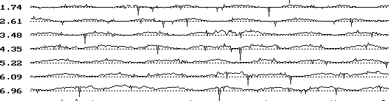 Picture 31 Tower crane in ports
Analyze as follows:
“” This kind of letter is called the unwanted signal, is caused by the wire rope interior containing the magnetism. The reason for having the magnetic may divide into two kinds, one kind is wire rope being struck by lightning, and the other kind is the production technology. When meeting this kind of signal, should degauss the rope first then to test, or test many times with the instrument.

6.3.1.4 Wire rope terminal nose effect
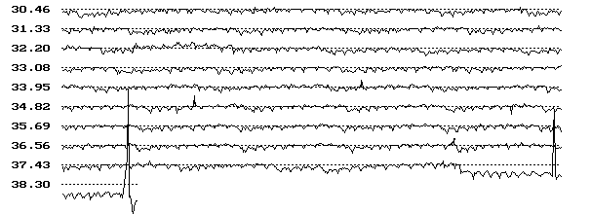Picture 32 Tower crane in ports
Analyze as follows:
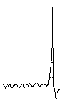 | This kind of letter is called ends effect, appears in the wire rope testing starting end and the termination end, is formed by testing starting sudden changes, and cannot be processed as the flaw signal.

6.3.2 Broken wire signal analyzing method
The wire rope broken wire generally be divided into: wearily broken wire, deterioration broken wire, tarnishing broken wire, cutting broken wire, overload broken wire, twisting broken wire and so on. Because the wire rope usually is composed by same diameter many root wires or different diameter many kinds of specifications wires, the surface is often rugged, the interior has the air clearance, is not the ferromagnetic material continual body. Therefore, when the wire rope is magnetized, in its superficial stray field, both has the broken wire stray field, and the background stray field (jet wave signal), brings the certain difficulty for us in the flaw qualitative.
6.3.2.1 Parameter adjustment method
Different structure wire ropes have different parameters. Correctly and reasonably choose parameter, may enable us to get twice the result with half the effort in the judgment process. (Each parameter definition seen in instruction).Magnification rate of wave form adjustment especially is important in them, this parameter is convenience to see the picture for the operator when judging, its parameter may be adjusted according to need.
Take a wave form below as the example:
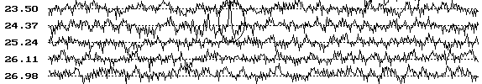Picture 33 Current Magnification rate of wave form: 6
May see from Picture 33, the flaw signal increases recognition difficulty under the jet wave signal disturbance, and is very difficult to identify. In the situation we can effectively reduce this kind of difficulty through the adjusting magnification rate of wave form, as the following Picture 34 shows:
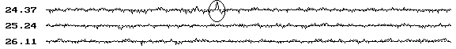Picture 34 Current Magnification rate of wave form: 2
Note: The magnification rate of wave form merely is used for the wave form size zooming, may enhance the Signal-to-Noise through the effective adjustment, reduce the difficulty to distinguish the flaw signal, has nothing to do with signal own withdrawing, the degree of regulation is convenience for is suitable to distinguish and analyze.
6.3.2.2 Crest values comparison method
Crest values comparison method, this kind of method is generally used in the condition of low Signal-to-Noise. Because of the wire rope structure different, wire rope diameter is also different. Therefore to different structure wire rope, one broken wire leakage magnetic is not same. In principle, the leakage magnetic that the thick wire rope broken wire is more than thin one, therefore the signal it produces would be big. In view of the thin wire rope broken wire, we may take comparison according to the signal characteristic and crest value, in threshold value has been adjusted situation.
As following Picture 35:
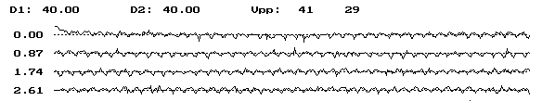Picture 35 Marked position VPP: 41, 29 (background signal VPP)
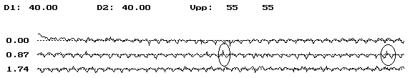Picture 36 Marked position VPP: 55, 55
May compare from this to obtain leakage magnetic produced in this two points is bigger than the marked position in Picture 35, two crest values data disparities equal, and the characteristic signal is obvious, namely the wave form crest is similar to the acute angle isosceles triangle, therefore we may determine it as broken wire signal.
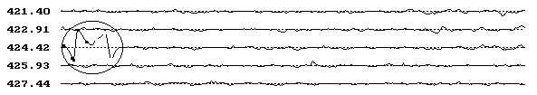
Picture 37 Special broken wire signals (Yuyang Coalmine hoisting rope)
This is the broken wire signal picture, space between two ends spacing is quite big, they have formed "M", can be judged as broke wire, besides be continuum broken wire.
The situation above is the common difficulty that will be met when we use the MTC series wire rope testing instrument, to want the skilled utilization and grasp, it needs us to accumulate experience in the routine work, so can digest it.

6.4 Wire Rope Diameter Evaluation
In MTC wire rope computer testing diagnosis system, wire rope diameter evaluation is through LMA testing signal to indirectly determine. Because the wire rope internal and external deterioration and tarnishing will reflect on the metallic cross-sectional area change, when the tarnishing is slight, wire rope diameter could be calculated by the cross-sectional area change.
For example, when wire rope outer layer wires are wear out to 2/3, the 6×19 wire rope metallic cross-sectional area will reduce by 1.54%, the 6×7 wire rope metallic cross-sectional area will reduce by 4.19%, and other structural wire rope metallic cross-sectional area reduction will be obtained through calculation.

6.5 Wire Rope Tarnishing Evaluation
Judging from the current domestic and international study of the status quo, the wire rope tarnishing evaluation had not had the appropriate method. But the wire rope tarnishing could be reflected through the cross-sectional area testing signal, when serious could be reflected through broken wire testing signal.

7 Note, Maintenance, Fault handling

7.1 Note
Before using charge the AD battery, and the battery could not continuous work surpass 9 hours.
Be sure not to operate wearing mechanical wristwatch, guard against the wristwatch magnetization.
Be sure not to put the sensor near the computer, the floppy disk, the printer, and guard against the strong magnetic field affection.
Be sure to remember the advance connecting lead plug, and then put through the power source starts the computer in turn.

7.2 Maintenance
The greasy dirt on the wire rope does not affect the testing result, but after each time testing finished, should clean greasy dir on the sensor the wrap and the encoder leading wheel.
The sensor probe is the precision instrument, should be put in ventilating dryly place. Because in its interior there are many kinds of miniature sensitive units, the user please not voluntarily disassembles, when the half spring below was locking, pushing the wrap with the hand careful is OK.

7.3 Fault handling
In the overall system use, there is generally not failure, but when the computer operation appears problem, may first ask the computer specialist to give detection guidance. If it is unable to solve, then please inform to supplier to make a service claim.

8. Appendix
The testing report
Product certificate
Packing list
Failure record
SHANGHAI QIEHUA VIRTUAL INSTRUMENT CO．，LTD
Technical Support： | 2nd Floor New Xuhui Business Center 33 No. 1480 Xietu Road Shanghai China
Manufacture： | Hangtou Nanhui Distinct Shanghai China
Tel： | 021-34160886 64045095 64162905
Fax： | 021-64181245
Post Code： | 200032
Http：//www.mtc312.com
E-mail：dongxinhua@online.sh.cn
The real-name network：钢丝绳检测仪 钢丝绳探伤仪器

